Rate

Rate
# Source: AI Source: Provided by: [Data Path: Persons Table -> ID Column: 1, Name_En Column: Motasem Essam] -> From: [ChatGPT] on [7/15/2026]
A Rate is a comparison of two quantities with different units, expressed as a quotient (division). A rate tells how much of one quantity corresponds to one unit of another quantity.
Rates are fundamental in arithmetic and are widely used in algebra, geometry, physics, chemistry, engineering, economics, finance, statistics, computer science, and everyday life.

Definition
# Source: AI Source: Provided by: [Data Path: Persons Table -> ID Column: 1, Name_En Column: Motasem Essam] -> From: [ChatGPT] on [7/15/2026]
A rate compares two quantities that have different units.
Examples include:
- kilometers per hour
- dollars per kilogram
- words per minute
- liters per second
- bytes per second
Unlike a ratio, the units do not cancel because they are different.

Rate Formula
# Source: AI Source: Provided by: [Data Path: Persons Table -> ID Column: 1, Name_En Column: Motasem Essam] -> From: [ChatGPT] on [7/15/2026]
If
- $A$is one quantity,
- $B$is another quantity with a different unit,
then the rate is
$$\boxed{\text{Rate}=\frac{A}{B}}$$
Units remain attached to the answer.

Unit Rate
# Source: AI Source: Provided by: [Data Path: Persons Table -> ID Column: 1, Name_En Column: Motasem Essam] -> From: [ChatGPT] on [7/15/2026]
A Unit Rate is a rate whose denominator is exactly 1 unit.
Examples:
- 60 km per hour
- $5 per kilogram
- 120 words per minute
The unit rate is found by dividing both quantities by the denominator.

Formula for Unit Rate
# Source: AI Source: Provided by: [Data Path: Persons Table -> ID Column: 1, Name_En Column: Motasem Essam] -> From: [ChatGPT] on [7/15/2026]
$$\boxed{\text{Unit Rate}=\frac{\text{Quantity}}{1\text{ unit}}}$$

Characteristics of Rates
# Source: AI Source: Provided by: [Data Path: Persons Table -> ID Column: 1, Name_En Column: Motasem Essam] -> From: [ChatGPT] on [7/15/2026]
- Compare quantities with different units.
- Units remain in the answer.
- Often expressed as "per".
- Frequently converted into unit rates for easier comparison.

Finding a Rate
# Source: AI Source: Provided by: [Data Path: Persons Table -> ID Column: 1, Name_En Column: Motasem Essam] -> From: [ChatGPT] on [7/15/2026]
Step 1
Identify the two quantities.

Step 2
Ensure the units are different.

Step 3
Divide the first quantity by the second quantity.

Step 4
Write the units correctly.

Examples
# Source: AI Source: Provided by: [Data Path: Persons Table -> ID Column: 1, Name_En Column: Motasem Essam] -> From: [ChatGPT] on [7/15/2026]
Example 1 – Speed
A car travels
$$240\text{ km}$$
in
$$4\text{ hours}.$$
Rate:
$$\frac{240}{4}=60$$
Answer:
$$60\text{ km/h}$$

Example 2 – Price
Five kilograms of apples cost
$$\$20.$$
Unit rate:
$$\frac{20}{5}=4$$
Answer:
$$\$4\text{/kg}$$

Example 3 – Typing Speed
A person types
$$420$$
words in
$$6$$
minutes.
Rate:
$$\frac{420}{6}=70$$
Answer:
$$70\text{ words/min}$$

Example 4 – Fuel Consumption
A car uses
$$30$$
liters for
$$500$$
km.
Rate:
$$\frac{30}{500}=0.06$$
Answer:
$$0.06\text{ L/km}$$

Example 5 – Internet Speed
A file of
$$600$$
MB downloads in
$$20$$
seconds.
Rate:
$$\frac{600}{20}=30$$
Answer:
$$30\text{ MB/s}$$

Example 6 – Salary
A worker earns
$$\$960$$
for
$$40$$
hours.
Hourly rate:
$$\frac{960}{40}=24$$
Answer:
$$\$24\text{/hour}$$

Unit Rate Examples
# Source: AI Source: Provided by: [Data Path: Persons Table -> ID Column: 1, Name_En Column: Motasem Essam] -> From: [ChatGPT] on [7/15/2026]
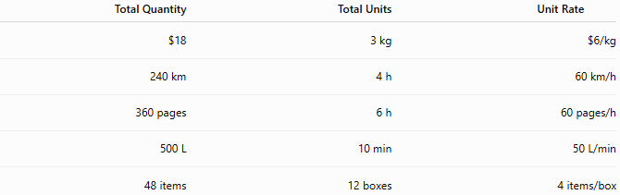
Total Quantity | Total Units | Unit Rate
$18 | 3 kg | $6/kg
240 km | 4 h | 60 km/h
360 pages | 6 h | 60 pages/h
500 L | 10 min | 50 L/min
48 items | 12 boxes | 4 items/box

Common Types of Rates
# Source: AI Source: Provided by: [Data Path: Persons Table -> ID Column: 1, Name_En Column: Motasem Essam] -> From: [ChatGPT] on [7/15/2026]
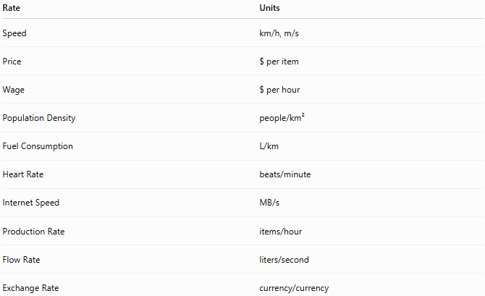
Rate | Units
Speed | km/h, m/s
Price | $ per item
Wage | $ per hour
Population Density | people/km²
Fuel Consumption | L/km
Heart Rate | beats/minute
Internet Speed | MB/s
Production Rate | items/hour
Flow Rate | liters/second
Exchange Rate | currency/currency

Applications
# Source: AI Source: Provided by: [Data Path: Persons Table -> ID Column: 1, Name_En Column: Motasem Essam] -> From: [ChatGPT] on [7/15/2026]
Rates are used in:
- Arithmetic
- Algebra
- Geometry
- Physics
- Chemistry
- Engineering
- Economics
- Finance
- Statistics
- Computer Science

Relationship to Other Topics
# Source: AI Source: Provided by: [Data Path: Persons Table -> ID Column: 1, Name_En Column: Motasem Essam] -> From: [ChatGPT] on [7/15/2026]
Rates are closely related to:
- Ratios
- Proportions
- Unit Rates
- Direct Proportion
- Inverse Proportion
- Fractions
- Percentages
- Speed
- Density
- Probability

Real-Life Applications
# Source: AI Source: Provided by: [Data Path: Persons Table -> ID Column: 1, Name_En Column: Motasem Essam] -> From: [ChatGPT] on [7/15/2026]
Rates are used in:
- Vehicle speed
- Fuel economy
- Hourly wages
- Shopping prices
- Internet bandwidth
- Water flow
- Machine production
- Population density
- Currency exchange
- Medical measurements

Real-Life Examples
# Source: AI Source: Provided by: [Data Path: Persons Table -> ID Column: 1, Name_En Column: Motasem Essam] -> From: [ChatGPT] on [7/15/2026]
1. Driving
Travel
$$180$$
km in
$$3$$
hours.
Rate:
$$60\text{ km/h}$$

2. Grocery Shopping
Rice costs
$$\$15$$
for
$$3$$
kg.
Unit rate:
$$\$5\text{/kg}$$

3. Salary
Weekly salary:
$$\$800$$
Working time:
$$40$$
hours.
Hourly rate:
$$\$20\text{/hour}$$

4. Internet
Download
$$900$$
MB in
$$30$$
seconds.
Rate:
$$30\text{ MB/s}$$

5. Factory
Produces
$$450$$
parts in
$$9$$
hours.
Rate:
$$50\text{ parts/hour}$$

6. Water Tank
A pipe fills
$$600$$
liters in
$$12$$
minutes.
Rate:
$$50\text{ L/min}$$

Common Mistakes
# Source: AI Source: Provided by: [Data Path: Persons Table -> ID Column: 1, Name_En Column: Motasem Essam] -> From: [ChatGPT] on [7/15/2026]
- Confusing a rate with a ratio.
- Forgetting to include units.
- Mixing incompatible units without conversion.
- Forgetting to simplify to a unit rate when requested.
- Reversing the numerator and denominator.

Key Points
# Source: AI Source: Provided by: [Data Path: Persons Table -> ID Column: 1, Name_En Column: Motasem Essam] -> From: [ChatGPT] on [7/15/2026]
- A rate compares different units.
- Units remain attached to the answer.
- A unit rate has a denominator of 1 unit.
- Rates are often written using the word "per".
- Rates are used extensively in science, engineering, economics, and everyday calculations.

Rate vs. Ratio
# Source: AI Source: Provided by: [Data Path: Persons Table -> ID Column: 1, Name_En Column: Motasem Essam] -> From: [ChatGPT] on [7/15/2026]
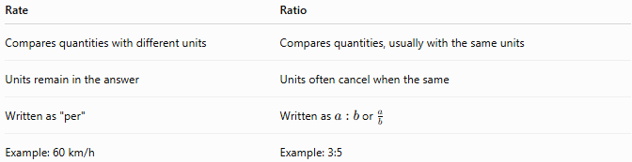
Rate | Ratio
Compares quantities with different units | Compares quantities, usually with the same units
Units remain in the answer | Units often cancel when the same
Written as "per" | Written as $a:b$or $\frac{a}{b}$
Example: 60 km/h | Example: 3:5

Rate vs. Unit Rate
# Source: AI Source: Provided by: [Data Path: Persons Table -> ID Column: 1, Name_En Column: Motasem Essam] -> From: [ChatGPT] on [7/15/2026]
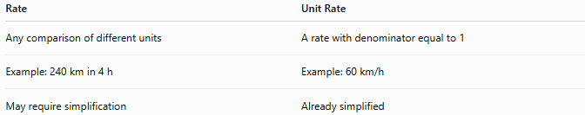
Rate | Unit Rate
Any comparison of different units | A rate with denominator equal to 1
Example: 240 km in 4 h | Example: 60 km/h
May require simplification | Already simplified

Direct Rate vs. Inverse Rate
# Source: AI Source: Provided by: [Data Path: Persons Table -> ID Column: 1, Name_En Column: Motasem Essam] -> From: [ChatGPT] on [7/15/2026]
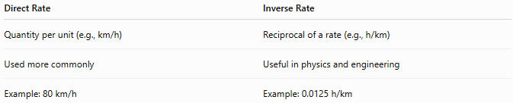
Direct Rate | Inverse Rate
Quantity per unit (e.g., km/h) | Reciprocal of a rate (e.g., h/km)
Used more commonly | Useful in physics and engineering
Example: 80 km/h | Example: 0.0125 h/km

Conclusion
# Source: AI Source: Provided by: [Data Path: Persons Table -> ID Column: 1, Name_En Column: Motasem Essam] -> From: [ChatGPT] on [7/15/2026]
A Rate is a comparison of two quantities with different units, expressed through division. It describes how much of one quantity corresponds to another and is commonly written using the word "per." A Unit Rate is a special type of rate with a denominator of one unit, making comparisons easier. Rates are essential in mathematics and are used extensively in science, engineering, finance, economics, transportation, manufacturing, and everyday decision-making.

Rate Change
# Source: AI Source: Provided by: [Data Path: Persons Table -> ID Column: 1, Name_En Column: Motasem Essam] -> From: [ChatGPT] on [7/15/2026]
A Rate Change describes how a rate changes over time or between two situations. It measures the difference between an original rate and a new rate, indicating whether the rate has increased, decreased, or remained constant.
Rate change is fundamental in arithmetic and is widely used in algebra, calculus, physics, engineering, economics, finance, statistics, computer science, and many real-world applications.

Definition
# Source: AI Source: Provided by: [Data Path: Persons Table -> ID Column: 1, Name_En Column: Motasem Essam] -> From: [ChatGPT] on [7/15/2026]
A Rate Change is the change in the value of a rate from one measurement to another.
If the original rate is
$$R_{1}$$
and the new rate is
$$R_{2},$$
then the rate has changed by
$$\boxed{R_{2}-R_{1}}$$

Formula for Rate Change
# Source: AI Source: Provided by: [Data Path: Persons Table -> ID Column: 1, Name_En Column: Motasem Essam] -> From: [ChatGPT] on [7/15/2026]
The absolute rate change is
$$\boxed{ΔR=R_{2}-R_{1}}$$
where
- $R_{1}$= original rate
- $R_{2}$= new rate

Percentage Rate Change
# Source: AI Source: Provided by: [Data Path: Persons Table -> ID Column: 1, Name_En Column: Motasem Essam] -> From: [ChatGPT] on [7/15/2026]
Sometimes the change is expressed as a percentage of the original rate.
$$\boxed{\%\text{ Rate Change}=\frac{R_{2}-R_{1}}{R_{1}}×100\%}$$

Types of Rate Change
# Source: AI Source: Provided by: [Data Path: Persons Table -> ID Column: 1, Name_En Column: Motasem Essam] -> From: [ChatGPT] on [7/15/2026]
A rate may:
- Increase
- Decrease
- Remain constant

Positive Rate Change
# Source: AI Source: Provided by: [Data Path: Persons Table -> ID Column: 1, Name_En Column: Motasem Essam] -> From: [ChatGPT] on [7/15/2026]
If
$$R_{2}>R_{1},$$
then
$$ΔR>0$$
The rate has increased.

Negative Rate Change
# Source: AI Source: Provided by: [Data Path: Persons Table -> ID Column: 1, Name_En Column: Motasem Essam] -> From: [ChatGPT] on [7/15/2026]
If
$$R_{2}<R_{1},$$
then
$$ΔR<0$$
The rate has decreased.

Zero Rate Change
# Source: AI Source: Provided by: [Data Path: Persons Table -> ID Column: 1, Name_En Column: Motasem Essam] -> From: [ChatGPT] on [7/15/2026]
If
$$R_{2}=R_{1},$$
then
$$ΔR=0$$
The rate has remained constant.

Constant Rate
# Source: AI Source: Provided by: [Data Path: Persons Table -> ID Column: 1, Name_En Column: Motasem Essam] -> From: [ChatGPT] on [7/15/2026]
A constant rate means there is no rate change.
For example, a car traveling at
$$60\text{ km/h}$$
throughout an entire trip has
$$ΔR=0.$$

Examples
# Source: AI Source: Provided by: [Data Path: Persons Table -> ID Column: 1, Name_En Column: Motasem Essam] -> From: [ChatGPT] on [7/15/2026]
Example 1 – Speed Increase
Original speed:
$$60\text{ km/h}$$
New speed:
$$80\text{ km/h}$$
Absolute change:
$$80-60=20\text{ km/h}$$
Percentage change:
$$\frac{20}{60}×100=33.33\%$$

Example 2 – Hourly Wage
Original wage:
$$\$18/\text{hour}$$
New wage:
$$\$24/\text{hour}$$
Absolute change:
$$6\text{ dollars/hour}$$
Percentage change:
$$\frac{6}{18}×100=33.33\%$$

Example 3 – Fuel Consumption
Original fuel usage:
$$0.08\text{ L/km}$$
New fuel usage:
$$0.06\text{ L/km}$$
Absolute change:
$$-0.02\text{ L/km}$$
Percentage change:
$$\frac{-0.02}{0.08}×100=-25\%$$

Example 4 – Internet Speed
Original download speed:
$$25\text{ MB/s}$$
New speed:
$$40\text{ MB/s}$$
Absolute change:
$$15\text{ MB/s}$$
Percentage change:
$$60\%$$

Example 5 – Printing Rate
Original:
$$30\text{ pages/min}$$
New:
$$45\text{ pages/min}$$
Absolute change:
$$15\text{ pages/min}$$
Percentage change:
$$50\%$$

Example 6 – Production Rate
Original:
$$120\text{ parts/hour}$$
New:
$$150\text{ parts/hour}$$
Absolute change:
$$30\text{ parts/hour}$$
Percentage change:
$$25\%$$

Rate Change Table
# Source: AI Source: Provided by: [Data Path: Persons Table -> ID Column: 1, Name_En Column: Motasem Essam] -> From: [ChatGPT] on [7/15/2026]
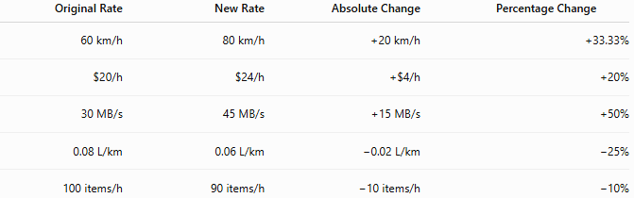
Original Rate | New Rate | Absolute Change | Percentage Change
60 km/h | 80 km/h | +20 km/h | +33.33%
$20/h | $24/h | +$4/h | +20%
30 MB/s | 45 MB/s | +15 MB/s | +50%
0.08 L/km | 0.06 L/km | −0.02 L/km | −25%
100 items/h | 90 items/h | −10 items/h | −10%

Applications
# Source: AI Source: Provided by: [Data Path: Persons Table -> ID Column: 1, Name_En Column: Motasem Essam] -> From: [ChatGPT] on [7/15/2026]
Rate change is used in:
- Arithmetic
- Algebra
- Calculus
- Physics
- Engineering
- Economics
- Finance
- Statistics
- Computer Science
- Data Analysis

Real-Life Applications
# Source: AI Source: Provided by: [Data Path: Persons Table -> ID Column: 1, Name_En Column: Motasem Essam] -> From: [ChatGPT] on [7/15/2026]
Rate change is used in:
- Vehicle acceleration
- Salary increases
- Fuel efficiency improvements
- Internet speed upgrades
- Production efficiency
- Population growth
- Inflation
- Currency exchange
- Stock market analysis
- Scientific experiments

Real-Life Examples
# Source: AI Source: Provided by: [Data Path: Persons Table -> ID Column: 1, Name_En Column: Motasem Essam] -> From: [ChatGPT] on [7/15/2026]
1. Driving
Speed increases from
$$50$$
km/h to
$$70$$
km/h.
Rate change:
$$20\text{ km/h}$$

2. Salary
Hourly wage increases from
$$\$25$$
to
$$\$30.$$
Rate change:
$$\$5/\text{hour}$$

3. Internet
Download speed increases from
$$100$$
MB/s to
$$250$$
MB/s.
Rate change:
$$150\text{ MB/s}$$

4. Factory
Production increases from
$$500$$
to
$$650$$
parts per hour.
Rate change:
$$150\text{ parts/hour}$$

5. Fuel Economy
Fuel consumption decreases from
$$0.09$$
to
$$0.07$$
L/km.
Rate change:
$$-0.02\text{ L/km}$$

6. Typing
Typing speed increases from
$$55$$
to
$$70$$
words per minute.
Rate change:
$$15\text{ words/min}$$

Common Mistakes
# Source: AI Source: Provided by: [Data Path: Persons Table -> ID Column: 1, Name_En Column: Motasem Essam] -> From: [ChatGPT] on [7/15/2026]
- Confusing rate with rate change.
- Ignoring the units of the rate.
- Reversing the subtraction order.
- Confusing absolute rate change with percentage rate change.
- Mixing different units without conversion.

Key Points
# Source: AI Source: Provided by: [Data Path: Persons Table -> ID Column: 1, Name_En Column: Motasem Essam] -> From: [ChatGPT] on [7/15/2026]
- Rate change measures how much a rate has increased or decreased.
- Positive values indicate an increase.
- Negative values indicate a decrease.
- Zero means the rate is constant.
- Rate change may be expressed as an absolute value or as a percentage.

Rate vs. Rate Change
# Source: AI Source: Provided by: [Data Path: Persons Table -> ID Column: 1, Name_En Column: Motasem Essam] -> From: [ChatGPT] on [7/15/2026]
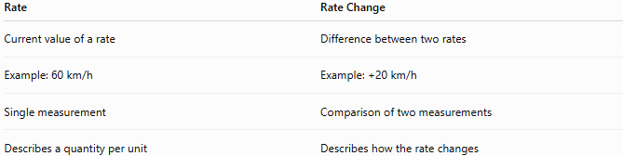
Rate | Rate Change
Current value of a rate | Difference between two rates
Example: 60 km/h | Example: +20 km/h
Single measurement | Comparison of two measurements
Describes a quantity per unit | Describes how the rate changes

Absolute Rate Change vs. Percentage Rate Change
# Source: AI Source: Provided by: [Data Path: Persons Table -> ID Column: 1, Name_En Column: Motasem Essam] -> From: [ChatGPT] on [7/15/2026]
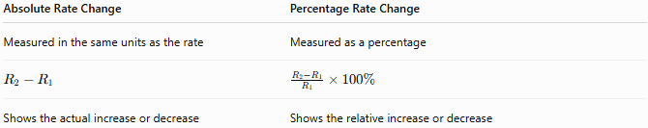
Absolute Rate Change | Percentage Rate Change
Measured in the same units as the rate | Measured as a percentage
$$R_{2}-R_{1}$$ | $$\frac{R_{2}-R_{1}}{R_{1}}×100\%$$
Shows the actual increase or decrease | Shows the relative increase or decrease

Rate Change vs. Average Rate of Change
# Source: AI Source: Provided by: [Data Path: Persons Table -> ID Column: 1, Name_En Column: Motasem Essam] -> From: [ChatGPT] on [7/15/2026]
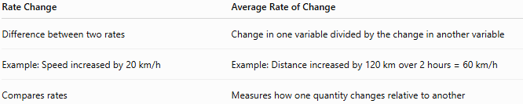
Rate Change | Average Rate of Change
Difference between two rates | Change in one variable divided by the change in another variable
Example: Speed increased by 20 km/h | Example: Distance increased by 120 km over 2 hours = 60 km/h
Compares rates | Measures how one quantity changes relative to another

Conclusion
# Source: AI Source: Provided by: [Data Path: Persons Table -> ID Column: 1, Name_En Column: Motasem Essam] -> From: [ChatGPT] on [7/15/2026]
A Rate Change measures the difference between an original rate and a new rate, indicating whether the rate has increased, decreased, or remained constant. It can be expressed as an absolute change using
$$ΔR=R_{2}-R_{1},$$
or as a percentage rate change
$$\frac{R_{2}-R_{1}}{R_{1}}×100\%.$$
Understanding rate change is essential for analyzing trends, comparing performance, and solving real-world problems in mathematics, science, engineering, economics, finance, and data analysis.

Direct Rate
# Source: AI Source: Provided by: [Data Path: Persons Table -> ID Column: 1, Name_En Column: Motasem Essam] -> From: [ChatGPT] on [7/15/2026]
A Direct Rate is a rate in which one quantity increases or decreases directly with another quantity while the rate remains constant. It is a practical application of direct proportion and is commonly expressed as "per" (such as kilometers per hour or dollars per kilogram).
Direct rates are fundamental in arithmetic and are widely used in algebra, physics, engineering, finance, economics, statistics, computer science, and everyday life.

Definition
# Source: AI Source: Provided by: [Data Path: Persons Table -> ID Column: 1, Name_En Column: Motasem Essam] -> From: [ChatGPT] on [7/15/2026]
A Direct Rate compares two quantities with different units where the amount of one quantity changes directly with the other.
If one quantity doubles, the other also doubles.
If one quantity triples, the other also triples.
The unit rate remains constant.

Mathematical Definition
# Source: AI Source: Provided by: [Data Path: Persons Table -> ID Column: 1, Name_En Column: Motasem Essam] -> From: [ChatGPT] on [7/15/2026]
If
- $A$is the first quantity,
- $B$is the second quantity,
then
$$\boxed{\text{Direct Rate}=\frac{A}{B}=k}$$
where
- $k$is the constant rate.
Equivalently,
$$\boxed{A=kB}$$
This is the same mathematical relationship as direct proportion.

Constant Rate
# Source: AI Source: Provided by: [Data Path: Persons Table -> ID Column: 1, Name_En Column: Motasem Essam] -> From: [ChatGPT] on [7/15/2026]
The constant rate is
$$\boxed{k=\frac{A}{B}}$$
The value of
$$k$$
remains constant for every corresponding pair of values.

Visualizing a Direct Rate
# Source: AI Source: Provided by: [Data Path: Persons Table -> ID Column: 1, Name_En Column: Motasem Essam] -> From: [ChatGPT] on [7/15/2026]
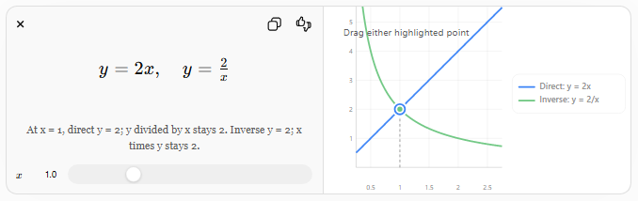
The direct proportion graph illustrates that when the rate is constant, doubling one quantity doubles the other.

Properties of Direct Rates
# Source: AI Source: Provided by: [Data Path: Persons Table -> ID Column: 1, Name_En Column: Motasem Essam] -> From: [ChatGPT] on [7/15/2026]
- The rate remains constant.
- Both quantities increase together.
- Both quantities decrease together.
- The graph is a straight line passing through the origin.
- The relationship follows
$$A=kB.$$

Finding a Direct Rate
# Source: AI Source: Provided by: [Data Path: Persons Table -> ID Column: 1, Name_En Column: Motasem Essam] -> From: [ChatGPT] on [7/15/2026]
Step 1
Identify the two quantities.

Step 2
Divide one quantity by the other.

Step 3
Write the units correctly.

Step 4
Use the unit rate to solve similar problems.

Examples
# Source: AI Source: Provided by: [Data Path: Persons Table -> ID Column: 1, Name_En Column: Motasem Essam] -> From: [ChatGPT] on [7/15/2026]
Example 1 – Speed
A car travels
$$240\text{ km}$$
in
$$4\text{ h}.$$
Direct rate:
$$\frac{240}{4}=60$$
Answer:
$$60\text{ km/h}$$

Example 2 – Hourly Wage
A worker earns
$$\$200$$
for
$$8$$
hours.
Rate:
$$\frac{200}{8}=25$$
Answer:
$$\$25/\text{hour}$$

Example 3 – Price
Five kilograms of apples cost
$$\$30.$$
Unit rate:
$$\frac{30}{5}=6$$
Answer:
$$\$6/\text{kg}$$

Example 4 – Printing
Printing
$$250$$
pages costs
$$\$50.$$
Rate:
$$\frac{50}{250}=0.20$$
Answer:
$$\$0.20/\text{page}$$

Example 5 – Fuel Consumption
A car uses
$$18$$
liters of fuel to travel
$$300$$
km.
Rate:
$$\frac{18}{300}=0.06$$
Answer:
$$0.06\text{ L/km}$$

Example 6 – Internet Download
A file of
$$900$$
MB downloads in
$$30$$
seconds.
Rate:
$$\frac{900}{30}=30$$
Answer:
$$30\text{ MB/s}$$

Direct Rate Table
# Source: AI Source: Provided by: [Data Path: Persons Table -> ID Column: 1, Name_En Column: Motasem Essam] -> From: [ChatGPT] on [7/15/2026]
Suppose a worker earns
$$\$15$$
per hour.

Hours | Earnings
1 | $15
2 | $30
4 | $60
6 | $90
8 | $120
10 | $150
Notice that
$$\frac{\text{Earnings}}{\text{Hours}}=15$$
for every row.

Graph of a Direct Rate
# Source: AI Source: Provided by: [Data Path: Persons Table -> ID Column: 1, Name_En Column: Motasem Essam] -> From: [ChatGPT] on [7/15/2026]
For
$$A=kB,$$
the graph:
- is a straight line,
- passes through
$$(0,0),$$
- has slope
$$k.$$

Applications
# Source: AI Source: Provided by: [Data Path: Persons Table -> ID Column: 1, Name_En Column: Motasem Essam] -> From: [ChatGPT] on [7/15/2026]
Direct rates are used in:
- Arithmetic
- Algebra
- Physics
- Engineering
- Economics
- Finance
- Statistics
- Computer Science
- Chemistry
- Manufacturing

Real-Life Applications
# Source: AI Source: Provided by: [Data Path: Persons Table -> ID Column: 1, Name_En Column: Motasem Essam] -> From: [ChatGPT] on [7/15/2026]
Direct rates are used in:
- Vehicle speed
- Hourly wages
- Shopping prices
- Fuel economy
- Printing costs
- Internet speed
- Water flow
- Manufacturing
- Electricity billing
- Currency exchange

Real-Life Examples
# Source: AI Source: Provided by: [Data Path: Persons Table -> ID Column: 1, Name_En Column: Motasem Essam] -> From: [ChatGPT] on [7/15/2026]
1. Taxi Fare
A taxi charges
$$\$2$$
per kilometer.
Traveling
$$15$$
km costs
$$\$30.$$

2. Salary
A programmer earns
$$\$40$$
per hour.
Working
$$10$$
hours earns
$$\$400.$$

3. Grocery Store
Rice costs
$$\$3$$
per kilogram.
Buying
$$7$$
kg costs
$$\$21.$$

4. Internet
Download speed:
$$50\text{ MB/s}$$
Downloading for
$$10$$
seconds transfers
$$500\text{ MB}.$$

5. Manufacturing
A machine produces
$$120$$
parts each hour.
After
$$5$$
hours it produces
$$600$$
parts.

6. Water Flow
A pipe delivers
$$40$$
liters each minute.
After
$$12$$
minutes:
$$480$$
liters.

Common Mistakes
# Source: AI Source: Provided by: [Data Path: Persons Table -> ID Column: 1, Name_En Column: Motasem Essam] -> From: [ChatGPT] on [7/15/2026]
- Confusing a direct rate with direct proportion (the direct rate is the constant value in a direct proportion).
- Forgetting to include units.
- Mixing incompatible units without converting them first.
- Reversing the numerator and denominator.
- Assuming every rate is constant.

Key Points
# Source: AI Source: Provided by: [Data Path: Persons Table -> ID Column: 1, Name_En Column: Motasem Essam] -> From: [ChatGPT] on [7/15/2026]
- A direct rate compares two quantities with different units.
- The unit rate remains constant.
- The relationship follows
$$A=kB.$$
- Doubling one quantity doubles the other.
- Direct rates are expressed using "per", such as km/h or $ per kg.

Direct Rate vs. Inverse Rate
# Source: AI Source: Provided by: [Data Path: Persons Table -> ID Column: 1, Name_En Column: Motasem Essam] -> From: [ChatGPT] on [7/15/2026]
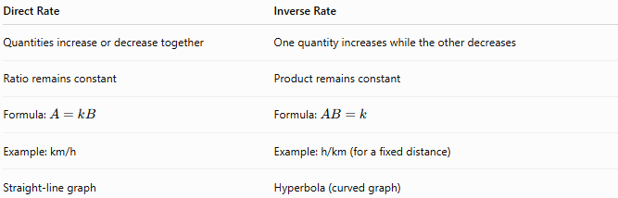
Direct Rate | Inverse Rate
Quantities increase or decrease together | One quantity increases while the other decreases
Ratio remains constant | Product remains constant
Formula: $A=kB$ | Formula: $AB=k$
Example: km/h | Example: h/km (for a fixed distance)
Straight-line graph | Hyperbola (curved graph)

Direct Rate vs. Unit Rate
# Source: AI Source: Provided by: [Data Path: Persons Table -> ID Column: 1, Name_En Column: Motasem Essam] -> From: [ChatGPT] on [7/15/2026]
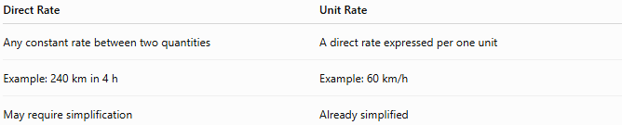
Direct Rate | Unit Rate
Any constant rate between two quantities | A direct rate expressed per one unit
Example: 240 km in 4 h | Example: 60 km/h
May require simplification | Already simplified

Conclusion
# Source: AI Source: Provided by: [Data Path: Persons Table -> ID Column: 1, Name_En Column: Motasem Essam] -> From: [ChatGPT] on [7/15/2026]
A Direct Rate is a constant comparison between two quantities with different units in which both quantities change together proportionally. It is mathematically represented by
$$A=kB,$$
where $k$is the constant rate. Direct rates are commonly expressed as unit rates (such as km/h, dollars per kilogram, or liters per minute) and are used extensively in mathematics, science, engineering, economics, finance, manufacturing, and everyday life to describe constant relationships between quantities.

Inverse Rate
# Source: AI Source: Provided by: [Data Path: Persons Table -> ID Column: 1, Name_En Column: Motasem Essam] -> From: [ChatGPT] on [7/15/2026]
An Inverse Rate is the reciprocal of a direct rate. It measures how much of the second quantity corresponds to one unit of the first quantity instead of how much of the first quantity corresponds to one unit of the second.
Inverse rates are commonly used in arithmetic, algebra, physics, engineering, transportation, economics, computer science, and many real-world applications.

Definition
# Source: AI Source: Provided by: [Data Path: Persons Table -> ID Column: 1, Name_En Column: Motasem Essam] -> From: [ChatGPT] on [7/15/2026]
An Inverse Rate is obtained by reversing the numerator and denominator of a direct rate.
If a direct rate is
$$\frac{A}{B},$$
then its inverse rate is
$$\boxed{\frac{B}{A}}$$
The units are also reversed.

Inverse Rate Formula
# Source: AI Source: Provided by: [Data Path: Persons Table -> ID Column: 1, Name_En Column: Motasem Essam] -> From: [ChatGPT] on [7/15/2026]
If the direct rate is
$$\boxed{\text{Direct Rate}=\frac{A}{B}}$$
then the inverse rate is
$$\boxed{\text{Inverse Rate}=\frac{B}{A}}$$

Relationship Between Direct and Inverse Rates
# Source: AI Source: Provided by: [Data Path: Persons Table -> ID Column: 1, Name_En Column: Motasem Essam] -> From: [ChatGPT] on [7/15/2026]
The two rates are reciprocals.
$$\boxed{\text{Inverse Rate}=\frac{1}{\text{Direct Rate}}}$$
and
$$\boxed{\text{Direct Rate}=\frac{1}{\text{Inverse Rate}}}$$

Units of an Inverse Rate
# Source: AI Source: Provided by: [Data Path: Persons Table -> ID Column: 1, Name_En Column: Motasem Essam] -> From: [ChatGPT] on [7/15/2026]
Reversing the rate also reverses the units.
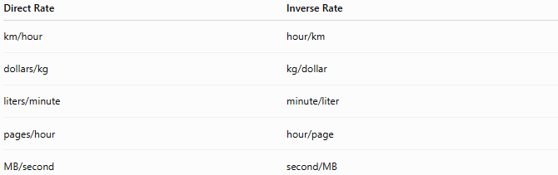
Direct Rate | Inverse Rate
km/hour | hour/km
dollars/kg | kg/dollar
liters/minute | minute/liter
pages/hour | hour/page
MB/second | second/MB

Finding an Inverse Rate
# Source: AI Source: Provided by: [Data Path: Persons Table -> ID Column: 1, Name_En Column: Motasem Essam] -> From: [ChatGPT] on [7/15/2026]
Step 1
Write the direct rate.

Step 2
Reverse the numerator and denominator.

Step 3
Reverse the units.

Examples
# Source: AI Source: Provided by: [Data Path: Persons Table -> ID Column: 1, Name_En Column: Motasem Essam] -> From: [ChatGPT] on [7/15/2026]
Example 1 – Speed
Direct rate:
$$60\text{ km/h}$$
Inverse rate:
$$\frac{1}{60}=0.0167$$
Answer:
$$0.0167\text{ h/km}$$
or approximately
$$1\text{ minute per kilometer}.$$

Example 2 – Hourly Wage
Direct rate:
$$\$25/\text{hour}$$
Inverse rate:
$$\frac{1}{25}=0.04$$
Answer:
$$0.04\text{ hour/dollar}$$

Example 3 – Fuel Consumption
Direct rate:
$$0.06\text{ L/km}$$
Inverse rate:
$$\frac{1}{0.06}=16.67$$
Answer:
$$16.67\text{ km/L}$$

Example 4 – Internet Download
Direct rate:
$$50\text{ MB/s}$$
Inverse rate:
$$\frac{1}{50}=0.02$$
Answer:
$$0.02\text{ s/MB}$$

Example 5 – Printing
Direct rate:
$$20\text{ pages/min}$$
Inverse rate:
$$\frac{1}{20}=0.05$$
Answer:
$$0.05\text{ min/page}$$

Example 6 – Water Flow
Direct rate:
$$40\text{ L/min}$$
Inverse rate:
$$\frac{1}{40}=0.025$$
Answer:
$$0.025\text{ min/L}$$

Inverse Rate Table
# Source: AI Source: Provided by: [Data Path: Persons Table -> ID Column: 1, Name_En Column: Motasem Essam] -> From: [ChatGPT] on [7/15/2026]
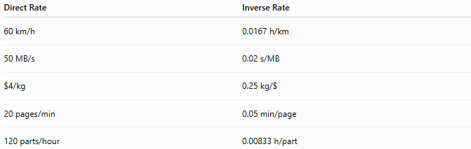
Direct Rate | Inverse Rate
60 km/h | 0.0167 h/km
50 MB/s | 0.02 s/MB
$4/kg | 0.25 kg/$
20 pages/min | 0.05 min/page
120 parts/hour | 0.00833 h/part

Applications
# Source: AI Source: Provided by: [Data Path: Persons Table -> ID Column: 1, Name_En Column: Motasem Essam] -> From: [ChatGPT] on [7/15/2026]
Inverse rates are used in:
- Arithmetic
- Algebra
- Physics
- Engineering
- Economics
- Finance
- Transportation
- Manufacturing
- Computer Science
- Scientific Computing

Real-Life Applications
# Source: AI Source: Provided by: [Data Path: Persons Table -> ID Column: 1, Name_En Column: Motasem Essam] -> From: [ChatGPT] on [7/15/2026]
Inverse rates are used in:
- Time required per unit of work
- Fuel efficiency
- Download time per megabyte
- Machine processing time
- Production scheduling
- Manufacturing
- Construction
- Medical dosing
- Transportation
- Computer performance

Real-Life Examples
# Source: AI Source: Provided by: [Data Path: Persons Table -> ID Column: 1, Name_En Column: Motasem Essam] -> From: [ChatGPT] on [7/15/2026]
1. Driving
Speed:
$$80\text{ km/h}$$
Inverse rate:
$$0.0125\text{ h/km}$$
Approximately
45 seconds per kilometer.

2. Typing
Typing speed:
$$60\text{ words/min}$$
Inverse rate:
$$0.0167\text{ min/word}$$

3. Internet
Download speed:
$$100\text{ MB/s}$$
Inverse rate:
$$0.01\text{ s/MB}$$

4. Factory
Machine produces
$$200$$
parts/hour.
Inverse rate:
$$0.005\text{ hour/part}$$

5. Fuel Economy
Fuel usage:
$$0.08\text{ L/km}$$
Inverse rate:
$$12.5\text{ km/L}$$

6. Printing
Printer speed:
$$30\text{ pages/min}$$
Inverse rate:
$$0.0333\text{ min/page}$$

Common Mistakes
# Source: AI Source: Provided by: [Data Path: Persons Table -> ID Column: 1, Name_En Column: Motasem Essam] -> From: [ChatGPT] on [7/15/2026]
- Forgetting to reverse the units.
- Assuming an inverse rate means an inverse proportion (they are different concepts).
- Forgetting to take the reciprocal.
- Mixing incompatible units.
- Confusing reciprocal values with percentage changes.

Key Points
# Source: AI Source: Provided by: [Data Path: Persons Table -> ID Column: 1, Name_En Column: Motasem Essam] -> From: [ChatGPT] on [7/15/2026]
- An inverse rate is the reciprocal of a direct rate.
- Reversing the rate also reverses the units.
- Direct and inverse rates represent the same relationship from different perspectives.
- The product of a direct rate and its inverse rate equals 1 (when using compatible units).
$$\text{Direct Rate}×\text{Inverse Rate}=1$$

Direct Rate vs. Inverse Rate
# Source: AI Source: Provided by: [Data Path: Persons Table -> ID Column: 1, Name_En Column: Motasem Essam] -> From: [ChatGPT] on [7/15/2026]
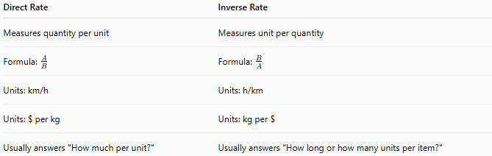
Direct Rate | Inverse Rate
Measures quantity per unit | Measures unit per quantity
Formula: $\frac{A}{B}$ | Formula: $\frac{B}{A}$
Units: km/h | Units: h/km
Units: $ per kg | Units: kg per $
Usually answers "How much per unit?" | Usually answers "How long or how many units per item?"

Inverse Rate vs. Inverse Proportion
# Source: AI Source: Provided by: [Data Path: Persons Table -> ID Column: 1, Name_En Column: Motasem Essam] -> From: [ChatGPT] on [7/15/2026]
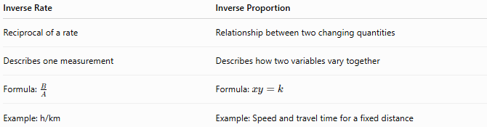
Inverse Rate | Inverse Proportion
Reciprocal of a rate | Relationship between two changing quantities
Describes one measurement | Describes how two variables vary together
Formula: $\frac{B}{A}$ | Formula: $xy=k$
Example: h/km | Example: Speed and travel time for a fixed distance

Conclusion
# Source: AI Source: Provided by: [Data Path: Persons Table -> ID Column: 1, Name_En Column: Motasem Essam] -> From: [ChatGPT] on [7/15/2026]
An Inverse Rate is the reciprocal of a direct rate and expresses one unit of the original denominator per one unit of the original numerator. It is found by reversing both the numerical value and the units of a direct rate. Inverse rates are widely used in transportation, engineering, manufacturing, computing, and science whenever it is more useful to express time per unit, distance per unit of fuel, or work per item instead of the corresponding direct rate. Understanding inverse rates helps in interpreting reciprocal measurements and complements the study of rates, proportions, and inverse relationships.

Unit Rate
# Source: AI Source: Provided by: [Data Path: Persons Table -> ID Column: 1, Name_En Column: Motasem Essam] -> From: [ChatGPT] on [7/15/2026]
A Unit Rate is a rate in which the second quantity (denominator) is exactly one unit. It tells how much of one quantity corresponds to a single unit of another quantity, making comparisons simple and meaningful.
Unit rates are fundamental in arithmetic and are widely used in algebra, geometry, physics, engineering, economics, finance, statistics, computer science, and everyday life.

Definition
# Source: AI Source: Provided by: [Data Path: Persons Table -> ID Column: 1, Name_En Column: Motasem Essam] -> From: [ChatGPT] on [7/15/2026]
A Unit Rate is a rate expressed per one unit.
It is obtained by dividing both quantities so that the denominator becomes
$$1.$$
Examples:
- 60 kilometers per hour
- $5 per kilogram
- 120 words per minute
- 30 megabytes per second

Unit Rate Formula
# Source: AI Source: Provided by: [Data Path: Persons Table -> ID Column: 1, Name_En Column: Motasem Essam] -> From: [ChatGPT] on [7/15/2026]
If
- $A$is one quantity,
- $B$is another quantity,
then the unit rate is
$$\boxed{\text{Unit Rate}=\frac{A}{B}\text{(per 1 unit of }B\text{)}}$$

Finding a Unit Rate
# Source: AI Source: Provided by: [Data Path: Persons Table -> ID Column: 1, Name_En Column: Motasem Essam] -> From: [ChatGPT] on [7/15/2026]
Step 1
Write the rate as a fraction.

Step 2
Divide the numerator by the denominator.

Step 3
Write the answer using "per one unit."

Properties of Unit Rates
# Source: AI Source: Provided by: [Data Path: Persons Table -> ID Column: 1, Name_En Column: Motasem Essam] -> From: [ChatGPT] on [7/15/2026]
- The denominator is always
$$1.$$
- Unit rates make comparisons easier.
- They preserve the original relationship.
- Units remain attached to the answer.

Examples
# Source: AI Source: Provided by: [Data Path: Persons Table -> ID Column: 1, Name_En Column: Motasem Essam] -> From: [ChatGPT] on [7/15/2026]
Example 1 – Speed
A car travels
$$240\text{ km}$$
in
$$4\text{ hours}.$$
Unit rate:
$$\frac{240}{4}=60$$
Answer:
$$60\text{ km/h}$$

Example 2 – Price
Five kilograms of apples cost
$$\$20.$$
Unit rate:
$$\frac{20}{5}=4$$
Answer:
$$\$4/\text{kg}$$

Example 3 – Salary
A worker earns
$$\$960$$
for
$$40$$
hours.
Unit rate:
$$\frac{960}{40}=24$$
Answer:
$$\$24/\text{hour}$$

Example 4 – Fuel Consumption
A car uses
$$18$$
liters of fuel for
$$300$$
km.
Unit rate:
$$\frac{18}{300}=0.06$$
Answer:
$$0.06\text{ L/km}$$

Example 5 – Typing
A person types
$$420$$
words in
$$6$$
minutes.
Unit rate:
$$\frac{420}{6}=70$$
Answer:
$$70\text{ words/min}$$

Example 6 – Internet Speed
A file of
$$900$$
MB downloads in
$$30$$
seconds.
Unit rate:
$$\frac{900}{30}=30$$
Answer:
$$30\text{ MB/s}$$

Unit Rate Table
# Source: AI Source: Provided by: [Data Path: Persons Table -> ID Column: 1, Name_En Column: Motasem Essam] -> From: [ChatGPT] on [7/15/2026]
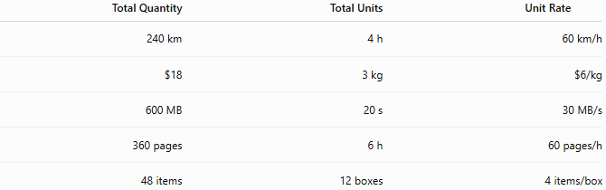
Total Quantity | Total Units | Unit Rate
240 km | 4 h | 60 km/h
$18 | 3 kg | $6/kg
600 MB | 20 s | 30 MB/s
360 pages | 6 h | 60 pages/h
48 items | 12 boxes | 4 items/box

Comparing Unit Rates
# Source: AI Source: Provided by: [Data Path: Persons Table -> ID Column: 1, Name_En Column: Motasem Essam] -> From: [ChatGPT] on [7/15/2026]
Unit rates make comparisons straightforward.

Example
Store A
$$\$12$$
for
$$3$$
kg
Unit rate:
$$\$4/\text{kg}$$
Store B
$$\$15$$
for
$$5$$
kg
Unit rate:
$$\$3/\text{kg}$$
Store B offers the lower price per kilogram.

Common Types of Unit Rates
# Source: AI Source: Provided by: [Data Path: Persons Table -> ID Column: 1, Name_En Column: Motasem Essam] -> From: [ChatGPT] on [7/15/2026]
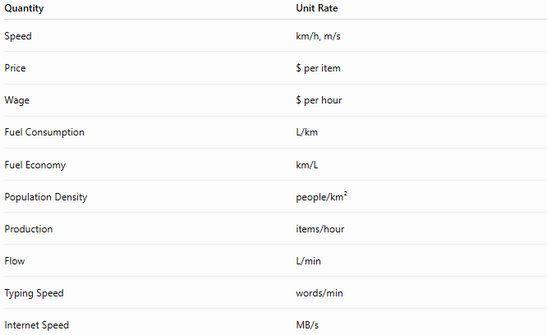
Quantity | Unit Rate
Speed | km/h, m/s
Price | $ per item
Wage | $ per hour
Fuel Consumption | L/km
Fuel Economy | km/L
Population Density | people/km²
Production | items/hour
Flow | L/min
Typing Speed | words/min
Internet Speed | MB/s

Applications
# Source: AI Source: Provided by: [Data Path: Persons Table -> ID Column: 1, Name_En Column: Motasem Essam] -> From: [ChatGPT] on [7/15/2026]
Unit rates are used in:
- Arithmetic
- Algebra
- Geometry
- Physics
- Engineering
- Finance
- Economics
- Statistics
- Computer Science
- Chemistry

Real-Life Applications
# Source: AI Source: Provided by: [Data Path: Persons Table -> ID Column: 1, Name_En Column: Motasem Essam] -> From: [ChatGPT] on [7/15/2026]
Unit rates are used in:
- Comparing grocery prices
- Vehicle speed
- Employee wages
- Fuel economy
- Internet bandwidth
- Manufacturing
- Water flow
- Electricity usage
- Construction
- Scientific measurements

Real-Life Examples
# Source: AI Source: Provided by: [Data Path: Persons Table -> ID Column: 1, Name_En Column: Motasem Essam] -> From: [ChatGPT] on [7/15/2026]
1. Grocery Shopping
Rice costs
$$\$15$$
for
$$3$$
kg.
Unit rate:
$$\$5/\text{kg}$$

2. Driving
Travel
$$180$$
km in
$$3$$
hours.
Unit rate:
$$60\text{ km/h}$$

3. Salary
Weekly salary:
$$\$800$$
for
$$40$$
hours.
Unit rate:
$$\$20/\text{hour}$$

4. Internet
Download
$$1200$$
MB in
$$40$$
seconds.
Unit rate:
$$30\text{ MB/s}$$

5. Factory
Produces
$$500$$
parts in
$$10$$
hours.
Unit rate:
$$50\text{ parts/hour}$$

6. Water Supply
A pipe delivers
$$720$$
liters in
$$12$$
minutes.
Unit rate:
$$60\text{ L/min}$$

Common Mistakes
# Source: AI Source: Provided by: [Data Path: Persons Table -> ID Column: 1, Name_En Column: Motasem Essam] -> From: [ChatGPT] on [7/15/2026]
- Forgetting to divide by the denominator.
- Omitting the units.
- Mixing different units without conversion.
- Confusing a rate with a unit rate.
- Reversing the numerator and denominator.

Key Points
# Source: AI Source: Provided by: [Data Path: Persons Table -> ID Column: 1, Name_En Column: Motasem Essam] -> From: [ChatGPT] on [7/15/2026]
- A unit rate has a denominator of exactly
$$1.$$
- Unit rates simplify comparisons.
- Units remain part of the answer.
- Most real-world rates are expressed as unit rates.
- Unit rates are found by dividing the numerator by the denominator.

Rate vs. Unit Rate
# Source: AI Source: Provided by: [Data Path: Persons Table -> ID Column: 1, Name_En Column: Motasem Essam] -> From: [ChatGPT] on [7/15/2026]
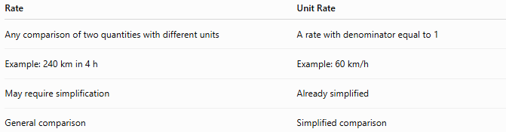
Rate | Unit Rate
Any comparison of two quantities with different units | A rate with denominator equal to 1
Example: 240 km in 4 h | Example: 60 km/h
May require simplification | Already simplified
General comparison | Simplified comparison

Direct Rate vs. Unit Rate
# Source: AI Source: Provided by: [Data Path: Persons Table -> ID Column: 1, Name_En Column: Motasem Essam] -> From: [ChatGPT] on [7/15/2026]
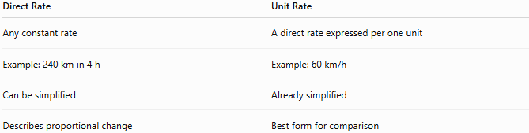
Direct Rate | Unit Rate
Any constant rate | A direct rate expressed per one unit
Example: 240 km in 4 h | Example: 60 km/h
Can be simplified | Already simplified
Describes proportional change | Best form for comparison

Unit Rate vs. Inverse Rate
# Source: AI Source: Provided by: [Data Path: Persons Table -> ID Column: 1, Name_En Column: Motasem Essam] -> From: [ChatGPT] on [7/15/2026]
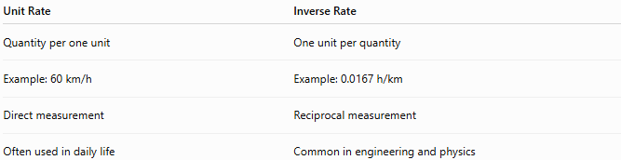
Unit Rate | Inverse Rate
Quantity per one unit | One unit per quantity
Example: 60 km/h | Example: 0.0167 h/km
Direct measurement | Reciprocal measurement
Often used in daily life | Common in engineering and physics

Conclusion
# Source: AI Source: Provided by: [Data Path: Persons Table -> ID Column: 1, Name_En Column: Motasem Essam] -> From: [ChatGPT] on [7/15/2026]
A Unit Rate is a rate expressed per one unit, making it the simplest and most useful form for comparing quantities. It is found by dividing one quantity by another so that the denominator becomes 1, while keeping the units attached. Unit rates are used extensively in mathematics and everyday life to compare prices, wages, speeds, fuel consumption, production, and many other measurements. Understanding unit rates provides a strong foundation for ratios, proportions, direct rates, inverse rates, percentages, and applied mathematics.

Absolute Rate Change
# Source: AI Source: Provided by: [Data Path: Persons Table -> ID Column: 1, Name_En Column: Motasem Essam] -> From: [ChatGPT] on [7/15/2026]
Absolute Rate Change is the actual numerical difference between two rates, measured in the same units as the original rate. It tells how much a rate has increased or decreased, without considering the percentage or relative size of the change.
Absolute rate change is widely used in arithmetic, algebra, physics, engineering, economics, finance, statistics, computer science, and real-world data analysis.

Definition
# Source: AI Source: Provided by: [Data Path: Persons Table -> ID Column: 1, Name_En Column: Motasem Essam] -> From: [ChatGPT] on [7/15/2026]
An Absolute Rate Change is the difference between a new rate and an original rate.
If
- $R_{1}$is the original rate,
- $R_{2}$is the new rate,
then the absolute rate change is
$$\boxed{ΔR=R_{2}-R_{1}}$$
The result has the same units as the rate.

Formula
# Source: AI Source: Provided by: [Data Path: Persons Table -> ID Column: 1, Name_En Column: Motasem Essam] -> From: [ChatGPT] on [7/15/2026]
$$\boxed{\text{Absolute Rate Change}=R_{2}-R_{1}}$$
where
- $R_{1}$= original rate
- $R_{2}$= new rate

Interpretation
# Source: AI Source: Provided by: [Data Path: Persons Table -> ID Column: 1, Name_En Column: Motasem Essam] -> From: [ChatGPT] on [7/15/2026]
If
$$ΔR>0$$
the rate increased.

If
$$ΔR<0$$
the rate decreased.

If
$$ΔR=0$$
the rate remained constant.

Units
# Source: AI Source: Provided by: [Data Path: Persons Table -> ID Column: 1, Name_En Column: Motasem Essam] -> From: [ChatGPT] on [7/15/2026]
Absolute rate change always has the same units as the original rate.
Examples:
- km/h
- dollars/hour
- MB/s
- pages/minute
- liters/minute
- items/hour

Examples
# Source: AI Source: Provided by: [Data Path: Persons Table -> ID Column: 1, Name_En Column: Motasem Essam] -> From: [ChatGPT] on [7/15/2026]
Example 1 – Speed
Original speed:
$$60\text{ km/h}$$
New speed:
$$80\text{ km/h}$$
Absolute rate change:
$$80-60=20\text{ km/h}$$

Example 2 – Salary
Original wage:
$$\$18/\text{hour}$$
New wage:
$$\$24/\text{hour}$$
Absolute rate change:
$$24-18=6\text{ dollars/hour}$$

Example 3 – Internet Speed
Original:
$$25\text{ MB/s}$$
New:
$$40\text{ MB/s}$$
Absolute rate change:
$$15\text{ MB/s}$$

Example 4 – Fuel Consumption
Original:
$$0.08\text{ L/km}$$
New:
$$0.06\text{ L/km}$$
Absolute rate change:
$$0.06-0.08=-0.02\text{ L/km}$$

Example 5 – Production
Original:
$$120\text{ parts/hour}$$
New:
$$150\text{ parts/hour}$$
Absolute rate change:
$$30\text{ parts/hour}$$

Example 6 – Typing Speed
Original:
$$55\text{ words/min}$$
New:
$$70\text{ words/min}$$
Absolute rate change:
$$15\text{ words/min}$$

Absolute Rate Change Table
# Source: AI Source: Provided by: [Data Path: Persons Table -> ID Column: 1, Name_En Column: Motasem Essam] -> From: [ChatGPT] on [7/15/2026]
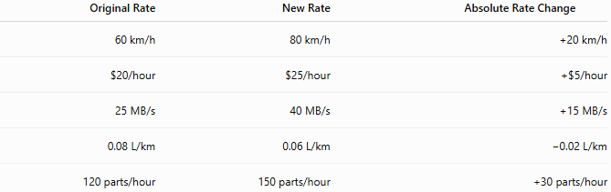
Original Rate | New Rate | Absolute Rate Change
60 km/h | 80 km/h | +20 km/h
$20/hour | $25/hour | +$5/hour
25 MB/s | 40 MB/s | +15 MB/s
0.08 L/km | 0.06 L/km | −0.02 L/km
120 parts/hour | 150 parts/hour | +30 parts/hour

Applications
# Source: AI Source: Provided by: [Data Path: Persons Table -> ID Column: 1, Name_En Column: Motasem Essam] -> From: [ChatGPT] on [7/15/2026]
Absolute rate change is used in:
- Arithmetic
- Algebra
- Physics
- Engineering
- Economics
- Finance
- Statistics
- Computer Science
- Manufacturing
- Data Analysis

Real-Life Applications
# Source: AI Source: Provided by: [Data Path: Persons Table -> ID Column: 1, Name_En Column: Motasem Essam] -> From: [ChatGPT] on [7/15/2026]
Absolute rate change is used in:
- Speed monitoring
- Salary adjustments
- Internet performance
- Machine productivity
- Fuel efficiency
- Population studies
- Manufacturing output
- Scientific experiments
- Financial analysis
- Sports performance

Real-Life Examples
# Source: AI Source: Provided by: [Data Path: Persons Table -> ID Column: 1, Name_En Column: Motasem Essam] -> From: [ChatGPT] on [7/15/2026]
1. Driving
Speed changes from
$$50$$
km/h to
$$70$$
km/h.
Absolute rate change:
$$20\text{ km/h}$$

2. Employee Salary
Hourly wage changes from
$$\$30$$
to
$$\$35.$$
Absolute rate change:
$$\$5/\text{hour}$$

3. Internet
Download speed changes from
$$100$$
MB/s to
$$250$$
MB/s.
Absolute rate change:
$$150\text{ MB/s}$$

4. Factory
Production changes from
$$500$$
to
$$650$$
parts/hour.
Absolute rate change:
$$150\text{ parts/hour}$$

5. Fuel Consumption
Fuel usage changes from
$$0.09$$
to
$$0.07$$
L/km.
Absolute rate change:
$$-0.02\text{ L/km}$$

6. Typing
Typing speed changes from
$$60$$
to
$$75$$
words/min.
Absolute rate change:
$$15\text{ words/min}$$

Common Mistakes
# Source: AI Source: Provided by: [Data Path: Persons Table -> ID Column: 1, Name_En Column: Motasem Essam] -> From: [ChatGPT] on [7/15/2026]
- Confusing absolute rate change with percentage rate change.
- Ignoring the units of the rate.
- Reversing the subtraction order.
- Mixing different units without conversion.
- Assuming a large absolute change always means a large relative change.

Key Points
# Source: AI Source: Provided by: [Data Path: Persons Table -> ID Column: 1, Name_En Column: Motasem Essam] -> From: [ChatGPT] on [7/15/2026]
- Absolute rate change is the difference between two rates.
- It has the same units as the rate.
- Positive values indicate an increase.
- Negative values indicate a decrease.
- Zero indicates no change.

Absolute Rate Change vs. Percentage Rate Change
# Source: AI Source: Provided by: [Data Path: Persons Table -> ID Column: 1, Name_En Column: Motasem Essam] -> From: [ChatGPT] on [7/15/2026]
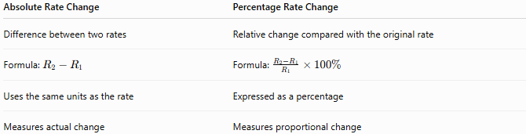

Absolute Rate Change | Percentage Rate Change
Difference between two rates | Relative change compared with the original rate
Formula: $R_{2}-R_{1}$ | Formula: $\frac{R_{2}-R_{1}}{R_{1}}×100\%$
Uses the same units as the rate | Expressed as a percentage
Measures actual change | Measures proportional change

Absolute Rate Change vs. Absolute Change
# Source: AI Source: Provided by: [Data Path: Persons Table -> ID Column: 1, Name_En Column: Motasem Essam] -> From: [ChatGPT] on [7/15/2026]
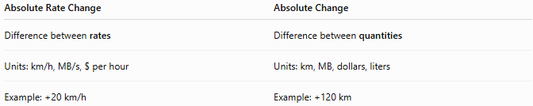
Absolute Rate Change | Absolute Change
Difference between rates | Difference between quantities
Units: km/h, MB/s, $ per hour | Units: km, MB, dollars, liters
Example: +20 km/h | Example: +120 km

Absolute Rate Change vs. Average Rate of Change
# Source: AI Source: Provided by: [Data Path: Persons Table -> ID Column: 1, Name_En Column: Motasem Essam] -> From: [ChatGPT] on [7/15/2026]
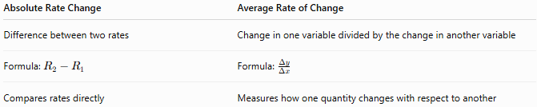
Absolute Rate Change | Average Rate of Change
Difference between two rates | Change in one variable divided by the change in another variable
Formula: $R_{2}-R_{1}$ | Formula: $\frac{Δy}{Δx}$
Compares rates directly | Measures how one quantity changes with respect to another

Conclusion
# Source: AI Source: Provided by: [Data Path: Persons Table -> ID Column: 1, Name_En Column: Motasem Essam] -> From: [ChatGPT] on [7/15/2026]
Absolute Rate Change measures the actual numerical difference between two rates and is calculated by
$$ΔR=R_{2}-R_{1}.$$
It retains the same units as the original rate and indicates whether the rate has increased, decreased, or remained constant. Unlike percentage rate change, absolute rate change focuses on the magnitude of the change itself, making it an essential tool for analyzing performance, trends, and measurements in mathematics, science, engineering, finance, economics, and everyday situations.

Percentage Rate Change
# Source: AI Source: Provided by: [Data Path: Persons Table -> ID Column: 1, Name_En Column: Motasem Essam] -> From: [ChatGPT] on [7/15/2026]
Percentage Rate Change measures how much a rate has increased or decreased relative to its original value, expressed as a percentage. It allows fair comparisons between changes in rates of different sizes.
Percentage rate change is widely used in arithmetic, algebra, economics, finance, engineering, statistics, computer science, physics, and many real-world applications.

Definition
# Source: AI Source: Provided by: [Data Path: Persons Table -> ID Column: 1, Name_En Column: Motasem Essam] -> From: [ChatGPT] on [7/15/2026]
A Percentage Rate Change is the percentage by which a rate changes from its original value.
If
- $R_{1}$is the original rate,
- $R_{2}$is the new rate,
then the percentage rate change is
$$\boxed{\%\text{ Rate Change}=\frac{R_{2}-R_{1}}{R_{1}}×100\%}$$

Formula
# Source: AI Source: Provided by: [Data Path: Persons Table -> ID Column: 1, Name_En Column: Motasem Essam] -> From: [ChatGPT] on [7/15/2026]
$$\boxed{\%\text{ Rate Change}=\frac{\text{New Rate}-\text{Original Rate}}{\text{Original Rate}}×100\%}$$
or
$$\boxed{\%\text{ Rate Change}=\frac{ΔR}{R_{1}}×100\%}$$
where
$$ΔR=R_{2}-R_{1}$$
is the absolute rate change.

Interpretation
# Source: AI Source: Provided by: [Data Path: Persons Table -> ID Column: 1, Name_En Column: Motasem Essam] -> From: [ChatGPT] on [7/15/2026]
If
$$\%\text{ Rate Change}>0$$
the rate increased.

If
$$\%\text{ Rate Change}<0$$
the rate decreased.

If
$$\%\text{ Rate Change}=0$$
the rate remained unchanged.

Steps to Calculate Percentage Rate Change
# Source: AI Source: Provided by: [Data Path: Persons Table -> ID Column: 1, Name_En Column: Motasem Essam] -> From: [ChatGPT] on [7/15/2026]
Step 1
Find the original rate.

Step 2
Find the new rate.

Step 3
Calculate the absolute rate change.
$$R_{2}-R_{1}$$

Step 4
Divide by the original rate.

Step 5
Multiply by
$$100\%$$

Examples
# Source: AI Source: Provided by: [Data Path: Persons Table -> ID Column: 1, Name_En Column: Motasem Essam] -> From: [ChatGPT] on [7/15/2026]
Example 1 – Speed
Original speed:
$$60\text{ km/h}$$
New speed:
$$80\text{ km/h}$$
Absolute change:
$$20$$
Percentage rate change:
$$\frac{20}{60}×100=33.33\%$$
Answer:
33.33% increase

Example 2 – Salary
Original wage:
$$\$20/\text{hour}$$
New wage:
$$\$25/\text{hour}$$
Percentage rate change:
$$\frac{5}{20}×100=25\%$$
Answer:
25% increase

Example 3 – Fuel Consumption
Original fuel usage:
$$0.08\text{ L/km}$$
New:
$$0.06\text{ L/km}$$
Percentage rate change:
$$\frac{-0.02}{0.08}×100=-25\%$$
Answer:
25% decrease

Example 4 – Internet Speed
Original:
$$25\text{ MB/s}$$
New:
$$40\text{ MB/s}$$
Percentage rate change:
$$\frac{15}{25}×100=60\%$$
Answer:
60% increase

Example 5 – Factory Production
Original:
$$120\text{ parts/hour}$$
New:
$$150\text{ parts/hour}$$
Percentage rate change:
$$\frac{30}{120}×100=25\%$$
Answer:
25% increase

Example 6 – Typing Speed
Original:
$$80\text{ words/min}$$
New:
$$68\text{ words/min}$$
Percentage rate change:
$$\frac{-12}{80}×100=-15\%$$
Answer:
15% decrease

Percentage Rate Change Table
# Source: AI Source: Provided by: [Data Path: Persons Table -> ID Column: 1, Name_En Column: Motasem Essam] -> From: [ChatGPT] on [7/15/2026]
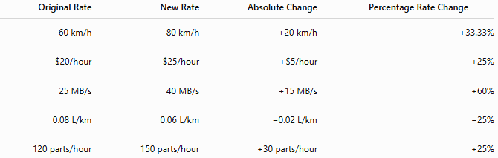
Original Rate | New Rate | Absolute Change | Percentage Rate Change
60 km/h | 80 km/h | +20 km/h | +33.33%
$20/hour | $25/hour | +$5/hour | +25%
25 MB/s | 40 MB/s | +15 MB/s | +60%
0.08 L/km | 0.06 L/km | −0.02 L/km | −25%
120 parts/hour | 150 parts/hour | +30 parts/hour | +25%

Applications
# Source: AI Source: Provided by: [Data Path: Persons Table -> ID Column: 1, Name_En Column: Motasem Essam] -> From: [ChatGPT] on [7/15/2026]
Percentage rate change is used in:
- Arithmetic
- Algebra
- Economics
- Finance
- Engineering
- Statistics
- Physics
- Computer Science
- Manufacturing
- Data Analysis

Real-Life Applications
# Source: AI Source: Provided by: [Data Path: Persons Table -> ID Column: 1, Name_En Column: Motasem Essam] -> From: [ChatGPT] on [7/15/2026]
Percentage rate change is used in:
- Salary raises
- Fuel efficiency improvements
- Internet speed upgrades
- Production efficiency
- Inflation analysis
- Stock market performance
- Population growth
- Economic indicators
- Business performance
- Scientific measurements

Real-Life Examples
# Source: AI Source: Provided by: [Data Path: Persons Table -> ID Column: 1, Name_En Column: Motasem Essam] -> From: [ChatGPT] on [7/15/2026]
1. Driving
Speed increases from
$$50$$
km/h to
$$75$$
km/h.
Percentage rate change:
$$\frac{25}{50}×100=50\%$$

2. Salary
Hourly wage increases from
$$\$24$$
to
$$\$30.$$
Percentage rate change:
$$25\%$$

3. Internet
Download speed increases from
$$100$$
MB/s to
$$250$$
MB/s.
Percentage rate change:
$$150\%$$

4. Factory
Production increases from
$$400$$
to
$$500$$
parts/hour.
Percentage rate change:
$$25\%$$

5. Fuel Consumption
Fuel usage decreases from
$$0.10$$
to
$$0.08$$
L/km.
Percentage rate change:
$$-20\%$$

6. Typing
Typing speed decreases from
$$100$$
to
$$90$$
words/min.
Percentage rate change:
$$-10\%$$

Common Mistakes
# Source: AI Source: Provided by: [Data Path: Persons Table -> ID Column: 1, Name_En Column: Motasem Essam] -> From: [ChatGPT] on [7/15/2026]
- Dividing by the new rate instead of the original rate.
- Forgetting to multiply by
$$100\%.$$
- Ignoring the sign of the result.
- Confusing percentage rate change with absolute rate change.
- Mixing different units before calculating.

Key Points
# Source: AI Source: Provided by: [Data Path: Persons Table -> ID Column: 1, Name_En Column: Motasem Essam] -> From: [ChatGPT] on [7/15/2026]
- Percentage rate change measures relative change.
- Always divide by the original rate.
- Positive values indicate an increase.
- Negative values indicate a decrease.
- A result of 0% means no change.

Percentage Rate Change vs. Absolute Rate Change
# Source: AI Source: Provided by: [Data Path: Persons Table -> ID Column: 1, Name_En Column: Motasem Essam] -> From: [ChatGPT] on [7/15/2026]
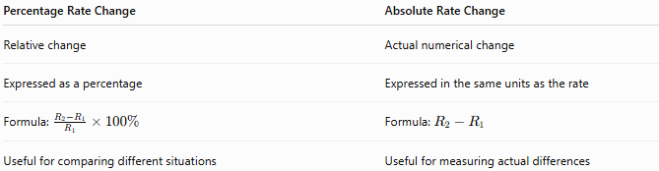
Percentage Rate Change | Absolute Rate Change
Relative change | Actual numerical change
Expressed as a percentage | Expressed in the same units as the rate
Formula: $\frac{R_{2}-R_{1}}{R_{1}}×100\%$ | Formula: $R_{2}-R_{1}$
Useful for comparing different situations | Useful for measuring actual differences

Percentage Rate Change vs. Percentage Change
# Source: AI Source: Provided by: [Data Path: Persons Table -> ID Column: 1, Name_En Column: Motasem Essam] -> From: [ChatGPT] on [7/15/2026]
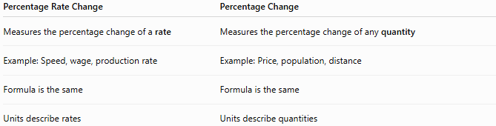
Percentage Rate Change | Percentage Change
Measures the percentage change of a rate | Measures the percentage change of any quantity
Example: Speed, wage, production rate | Example: Price, population, distance
Formula is the same | Formula is the same
Units describe rates | Units describe quantities

Percentage Rate Change vs. Growth Rate
# Source: AI Source: Provided by: [Data Path: Persons Table -> ID Column: 1, Name_En Column: Motasem Essam] -> From: [ChatGPT] on [7/15/2026]
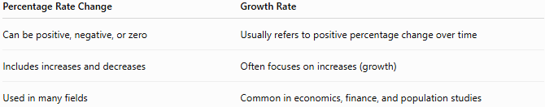
Percentage Rate Change | Growth Rate
Can be positive, negative, or zero | Usually refers to positive percentage change over time
Includes increases and decreases | Often focuses on increases (growth)
Used in many fields | Common in economics, finance, and population studies

Conclusion
# Source: AI Source: Provided by: [Data Path: Persons Table -> ID Column: 1, Name_En Column: Motasem Essam] -> From: [ChatGPT] on [7/15/2026]
Percentage Rate Change measures the relative increase or decrease of a rate compared with its original value. It is calculated by
$$\frac{R_{2}-R_{1}}{R_{1}}×100\%.$$
Unlike absolute rate change, which measures the actual numerical difference, percentage rate change expresses the change as a percentage, making it easier to compare rates of different magnitudes. It is an essential concept in mathematics and is widely applied in economics, finance, engineering, science, business, and everyday decision-making.

Average Rate of Change
# Source: AI Source: Provided by: [Data Path: Persons Table -> ID Column: 1, Name_En Column: Motasem Essam] -> From: [ChatGPT] on [7/15/2026]
The Average Rate of Change (AROC) measures how much one quantity changes, on average, for each unit change in another quantity over a specified interval. It tells us the average speed of change between two values.
Average rate of change is a fundamental concept in arithmetic, algebra, geometry, calculus, physics, engineering, economics, finance, statistics, computer science, and many real-world applications.

Definition
# Source: AI Source: Provided by: [Data Path: Persons Table -> ID Column: 1, Name_En Column: Motasem Essam] -> From: [ChatGPT] on [7/15/2026]
The Average Rate of Change is the ratio of the change in one quantity to the change in another quantity.
If
- $x_{1}$and $x_{2}$are two input values,
- $y_{1}$and $y_{2}$are the corresponding output values,
then
$$\boxed{\text{Average Rate of Change}=\frac{y_{2}-y_{1}}{x_{2}-x_{1}}}$$

Formula
# Source: AI Source: Provided by: [Data Path: Persons Table -> ID Column: 1, Name_En Column: Motasem Essam] -> From: [ChatGPT] on [7/15/2026]
$$\boxed{\text{Average Rate of Change}=\frac{Δy}{Δx}}$$
where
$$Δy=y_{2}-y_{1}$$
is the change in the dependent variable, and
$$Δx=x_{2}-x_{1}$$
is the change in the independent variable.

Interpretation
# Source: AI Source: Provided by: [Data Path: Persons Table -> ID Column: 1, Name_En Column: Motasem Essam] -> From: [ChatGPT] on [7/15/2026]
The average rate of change represents
the average amount that $y$changes for every one-unit increase in $x$.

Units
# Source: AI Source: Provided by: [Data Path: Persons Table -> ID Column: 1, Name_En Column: Motasem Essam] -> From: [ChatGPT] on [7/15/2026]
The units are determined by the variables involved.
Examples:
- kilometers per hour (km/h)
- dollars per hour ($/h)
- meters per second (m/s)
- liters per minute (L/min)
- pages per minute (pages/min)
- degrees Celsius per hour (°C/h)

Examples
# Source: AI Source: Provided by: [Data Path: Persons Table -> ID Column: 1, Name_En Column: Motasem Essam] -> From: [ChatGPT] on [7/15/2026]
Example 1 – Distance
A car travels
- 120 km in 2 hours
- 300 km in 5 hours
Average rate of change:
$$\frac{300-120}{5-2}=\frac{180}{3}=60$$
Answer:
$$60\text{ km/h}$$

Example 2 – Salary
Hours worked:
- 10 hours → $250
- 18 hours → $450
Average rate:
$$\frac{450-250}{18-10}=\frac{200}{8}=25$$
Answer:
$$\$25/\text{hour}$$

Example 3 – Water Flow
Water collected:
- 40 liters after 2 minutes
- 100 liters after 5 minutes
Average rate:
$$\frac{100-40}{5-2}=20$$
Answer:
$$20\text{ L/min}$$

Example 4 – Internet Download
Downloaded:
- 200 MB after 10 seconds
- 500 MB after 25 seconds
Average rate:
$$\frac{500-200}{25-10}=20$$
Answer:
$$20\text{ MB/s}$$

Example 5 – Temperature
Temperature:
- 18°C at 8 AM
- 30°C at 2 PM
Average rate:
$$\frac{30-18}{14-8}=2$$
Answer:
$$2^{∘}\text{C/hour}$$

Example 6 – Production
Factory output:
- 300 parts after 4 hours
- 540 parts after 10 hours
Average rate:
$$\frac{540-300}{10-4}=40$$
Answer:
$$40\text{ parts/hour}$$

Average Rate of Change Table
# Source: AI Source: Provided by: [Data Path: Persons Table -> ID Column: 1, Name_En Column: Motasem Essam] -> From: [ChatGPT] on [7/15/2026]
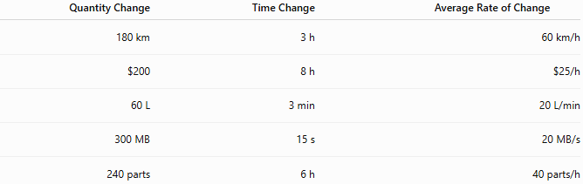
Quantity Change | Time Change | Average Rate of Change
180 km | 3 h | 60 km/h
$200 | 8 h | $25/h
60 L | 3 min | 20 L/min
300 MB | 15 s | 20 MB/s
240 parts | 6 h | 40 parts/h

Graphical Interpretation
# Source: AI Source: Provided by: [Data Path: Persons Table -> ID Column: 1, Name_En Column: Motasem Essam] -> From: [ChatGPT] on [7/15/2026]
For a graph of a function, the average rate of change between two points is the slope of the secant line joining those points.
If the graph is a straight line, the average rate of change is constant.
If the graph is curved, the average rate of change depends on the chosen interval.

Applications
# Source: AI Source: Provided by: [Data Path: Persons Table -> ID Column: 1, Name_En Column: Motasem Essam] -> From: [ChatGPT] on [7/15/2026]
Average rate of change is used in:
- Arithmetic
- Algebra
- Geometry
- Calculus
- Physics
- Engineering
- Economics
- Finance
- Statistics
- Computer Science

Real-Life Applications
# Source: AI Source: Provided by: [Data Path: Persons Table -> ID Column: 1, Name_En Column: Motasem Essam] -> From: [ChatGPT] on [7/15/2026]
Average rate of change is used in:
- Vehicle speed
- Salary calculations
- Manufacturing
- Internet performance
- Population growth
- Financial investments
- Scientific experiments
- Weather analysis
- Medical monitoring
- Sports statistics

Real-Life Examples
# Source: AI Source: Provided by: [Data Path: Persons Table -> ID Column: 1, Name_En Column: Motasem Essam] -> From: [ChatGPT] on [7/15/2026]
1. Driving
A car travels
240 km
in
4 hours.
Average rate:
$$60\text{ km/h}$$

2. Employee
A worker earns
$600
over
24 hours.
Average rate:
$$\$25/\text{hour}$$

3. Internet
900 MB downloaded in
30 seconds.
Average rate:
$$30\text{ MB/s}$$

4. Factory
480 products produced in
12 hours.
Average rate:
$$40\text{ products/hour}$$

5. Population
A city grows from
120,000
to
150,000
people in
10 years.
Average growth rate:
$$3000\text{ people/year}$$

6. Water Tank
A tank fills from
100 L
to
220 L
in
6 minutes.
Average filling rate:
$$20\text{ L/min}$$

Common Mistakes
# Source: AI Source: Provided by: [Data Path: Persons Table -> ID Column: 1, Name_En Column: Motasem Essam] -> From: [ChatGPT] on [7/15/2026]
- Dividing by the wrong change.
- Mixing units.
- Forgetting that the denominator must represent the change in the independent variable.
- Confusing average rate of change with instantaneous rate of change.
- Reversing the subtraction order.

Key Points
# Source: AI Source: Provided by: [Data Path: Persons Table -> ID Column: 1, Name_En Column: Motasem Essam] -> From: [ChatGPT] on [7/15/2026]
- Average rate of change measures change per unit.
- It is calculated using
$$\frac{Δy}{Δx}.$$
- Units depend on the quantities involved.
- For straight-line relationships, it is constant.
- For curved relationships, it depends on the interval.

Average Rate of Change vs. Rate
# Source: AI Source: Provided by: [Data Path: Persons Table -> ID Column: 1, Name_En Column: Motasem Essam] -> From: [ChatGPT] on [7/15/2026]
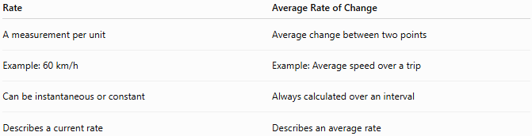
Rate | Average Rate of Change
A measurement per unit | Average change between two points
Example: 60 km/h | Example: Average speed over a trip
Can be instantaneous or constant | Always calculated over an interval
Describes a current rate | Describes an average rate

Average Rate of Change vs. Absolute Rate Change
# Source: AI Source: Provided by: [Data Path: Persons Table -> ID Column: 1, Name_En Column: Motasem Essam] -> From: [ChatGPT] on [7/15/2026]
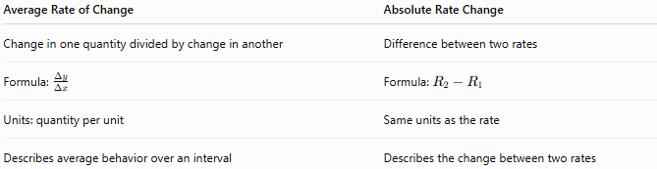
Average Rate of Change | Absolute Rate Change
Change in one quantity divided by change in another | Difference between two rates
Formula: $\frac{Δy}{Δx}$ | Formula: $R_{2}-R_{1}$
Units: quantity per unit | Same units as the rate
Describes average behavior over an interval | Describes the change between two rates

Average Rate of Change vs. Instantaneous Rate of Change
# Source: AI Source: Provided by: [Data Path: Persons Table -> ID Column: 1, Name_En Column: Motasem Essam] -> From: [ChatGPT] on [7/15/2026]
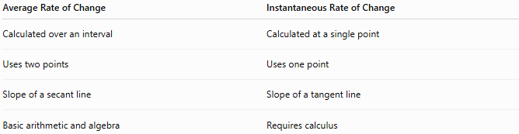
Average Rate of Change | Instantaneous Rate of Change
Calculated over an interval | Calculated at a single point
Uses two points | Uses one point
Slope of a secant line | Slope of a tangent line
Basic arithmetic and algebra | Requires calculus

Conclusion
# Source: AI Source: Provided by: [Data Path: Persons Table -> ID Column: 1, Name_En Column: Motasem Essam] -> From: [ChatGPT] on [7/15/2026]
The Average Rate of Change measures how much one quantity changes, on average, for each unit change in another quantity over a specified interval. It is calculated by
$$\frac{y_{2}-y_{1}}{x_{2}-x_{1}},$$
and represents the average change per unit. It is a foundational concept for understanding rates, linear relationships, motion, growth, and many real-world processes, while also serving as the bridge to the concept of the instantaneous rate of change in calculus.

